
BELOVED COMMUNITY WEEKEND WRAP-UP
Gregory Rouillard, Facilitator

TODAY @ MqtUU 1 – 4 PM

All are welcome to join us for discussion on
“Awareness of Power and Decision Making”
Much gratitude to Gregory Rouillard, M.Div., who envisions a world where people live, work, and play in nurturing communities, moving together in connection toward achieving effective outcomes and shares his philosophy and practice of Compassionate Communication provides Unitarian Universalists with concrete tools to bring the seven principles to life.

Also great thanks to Dea Kowalczyk and Dharmini Robertson for funding of this most awesome weekend!

MqtUU Autumn Open House
Wednesday, September 21 @ 5pm

ALL ARE WELCOME!!

The attendance of all members is requested! Bring the whole family, a dish to pass and share information with our neighbors about UUism and our Faith Community! Committee Chairs & Members are asked to present info on their mission, accomplishments & goals. We will be celebrating 10 years in our building. presenting our new sign, and enjoying food, fun and fellowship! Volunteers for grilling & greeting will be needed. Please contact Heidi mqtuuadassist@gmail.com.
SEPTEMBER “Share the Plate” Recipient:

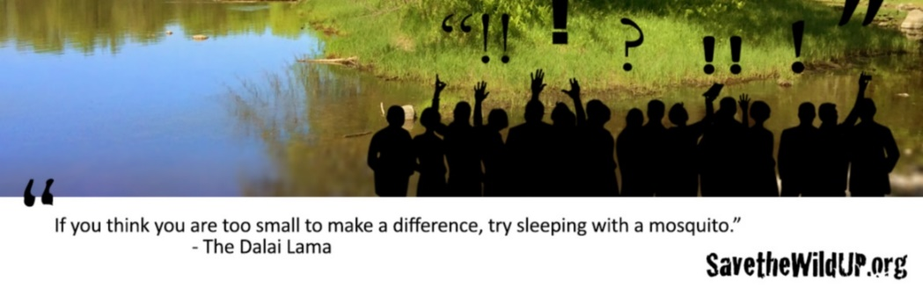
Grassroots opposition to Aquila’s Back Forty metallic sulfide mine next to the Menominee River has sponsored public forums on the cultural, environmental and economic impacts of the proposed mine. Save the Menominee River Speaking Tour sponsored previous forums in Marinette, WI and Menominee and Stephenson, MI.
Speakers from groups including the Menominee Indian Tribe of Wisconsin, the River Alliance of Wisconsin, the Front 40 citizens group and the Wisconsin Resources Protection Council have presented information about mining impacts, including the endangered sturgeon population in the Menominee River if the proposed open pit mine goes forward. Please support Save the Wild U.P. (S.W.U.P.)

FROM: 

"Out beyond ideas of wrongdoing and rightdoing, there is a field. I'll meet you there." —Rumi

Prayer
May we be called out into the fields of our longing and belonging. Open our souls this day to being human together.

